 | 26.2 Editors - Properties Editor - Render Properties Tab
Table of content
Detailed Table of content 1
Render Tab 10
Color Management panel - All Renderers 11
Cycles and Eevee - Freestyle panel 15
Cycles - Sampling panel 16
Cycles - Light Paths panel 21
Cycles - Volumes panel 24
Cycles - Curves panel 24
Cycles - Simplify panel 25
Cycles - Motion Blur panel 27
Cycles - Film panel 29
Cycles - Performance panel 29
Cycles - Bake panel 31
Workbench - Lighting panel 35
Workbench - Color panel 36
Workbench - Options panel 37
Eevee - Sampling panel 38
Eevee - Ambient Occlusion panel 39
Eevee - Bloom panel 39
Eevee - Depth of Field panel 40
Eevee - Subsurface Scattering panel 41
Eevee - Screen Space reflections panel 41
Eevee - Motion Blur panel 42
Eevee - Volumetric panel 43
Eevee - Curves panel 44
Eevee - Shadows panel 44
Eevee - Indirect Lighting panel 45
Eevee - Film panel 46
Eevee + Workbench - Simplify panel 46

Detailed Table of content

Detailed table of content
Detailed Table of content 1
Render Tab 10
Cycles Feature Set 10
Cycles Device 11
Open Shading Language 11
Color Management panel - All Renderers 11
Display Device 11
View Transform 11
Standard 11
AgX 12
Filmic 12
Filmic Log 12
Raw 12
False Color 12
Look 12
Exposure 12
Gamma 12
Sequencer Color Space 13
Display subpanel 13
Use Curves subpanel 13
Navigation elements 13
Zoom in and out 13
Tools 13
Reset View 13
Vector Handle 14
Auto Handle 14
Auto Clamped Handle 14
Extend Horizontal 14
Extend Extrapolated 14
Reset Curve 14
Use Clipping 14
Delete Points 14
Black Level 14
White Level 14
Hotkeys for Black and White Level 14
Reset 15
Cycles and Eevee - Freestyle panel 15
What is FreeStyle? 15
Enable 16
Line Thickness Mode 16
Absolute 16
Relative 16
Line Thickness 16
Cycles - Sampling panel 16
Viewport subpanel 17
Presets 17
Adaptive Sampling 17
Adaptive sampling threshold 17
Max Samples 17
Min Samples 17
Samples 17
Denoise Sub Subpanel 17
Use Denoising Checkbox 17
Denoiser 17
Automatic 17
OptiX 17
OpenImageDenoiser 18
Passes 18
Start Sample 18
Render subpanel 18
Presets 18
Adaptive sampling threshold 18
Max Samples 18
Min Samples 18
Samples 18
Time Limit 18
Denoise Sub Subpanel 19
Use Denoising Checkbox 19
Denoiser 19
Automatic 19
OptiX 19
OpenImageDenoiser 19
Passes 19
Start Sample 19
Path Guiding subpanel 19
Training Samples 19
Surface 19
Volume 19
Lights subpanel 20
Light Tree 20
Light Threshold 20
Advanced subpanel 20
Seed 20
Animate Seed 20
Pattern 20
Sobol 20
Progressive Multi-Jitter 20
Sample Offset 20
Scrambling Distance 21
Adaptive 21
Viewport 21
Min Light Bounces 21
Min Transparent Bounces 21
Light Threshold 21
Cycles - Light Paths panel 21
Presets 21
Max Bounces 22
Total 22
Diffuse 22
Glossy 22
Transmission Bounces 22
Volume 22
Transparent 22
Clamping 22
Direct Light 22
Indirect Light 22
Caustics 22
Filter Glossy 23
Reflective Caustics 23
Refractive Caustics 23
Fast GI approximation subpanel 23
Fast GI Approximation checkbox 23
Method 23
Replace 23
AO Factor 23
AO Distance 23
Viewport Bounces 24
Render Bounces 24
Add 24
AO Factor 24
AO Distance 24
Cycles - Volumes panel 24
Step Rate Render 24
Step Rate Viewport 24
Max Steps 24
Cycles - Curves panel 24
Shape 25
Curve Subdivisions 25
Viewport Display subpanel 25
Shape 25
Additional Subdiv 25
Cycles - Simplify panel 25
Enable 25
Viewport 25
Max Subdivisions 25
Child Particles 25
Texture Limit 25
AO Bounces 25
Volume Resolution 26
Render 26
Max Subdivisions 26
Child Particles 26
Texture Limit 26
Culling 26
Use Camera Cull 26
Camera cull margin 26
Use Distance Cull 26
Distance 26
Grease Pencil 26
Playback Only 26
Fill 27
Modifiers 27
Shader Effects 27
Layers Tinting 27
Antialiasing 27
Cycles - Motion Blur panel 27
Enable 27
Position 27
Shutter 27
Rolling Shutter 27
Duration 27
Shutter Curve 28
Navigation elements 28
Zoom in and out 28
Tools 28
Reset View 28
Vector Handle 28
Auto Handle 28
Auto Clamped Handle 28
Extend Horizontal 28
Extend Extrapolated 28
Reset Curve 28
Use Clipping 28
Delete Points 28
X and Y values 28
Presets 29
Cycles - Film panel 29
Exposure 29
Pixel Filter 29
Type 29
Width 29
Cycles - Performance panel 29
Presets 29
Default 29
Faster Rendering 29
Lower Memory 29
Threads 30
Mode 30
Auto-detect 30
Fixed 30
Threads 30
Memory 30
Auto Tiles 30
Tile Size 30
Acceleration Structure 30
Use Spatial Splits 30
With CPU rendering: 30
Use compact BVH 30
With GPU rendering: 30
BVH Time Steps 30
Use Hair BVH 31
Final Render 31
Persistent Data 31
Viewport 31
Pixel Size 31
Cycles - Bake panel 31
Settings for all Texture types 31
Bake Button 32
Bake from Multires 32
Bake Type 32
Combined 32
Ambient Occlusion 32
Shadow 32
Position 32
Normal 32
UV 32
Roughness 32
Emit 32
Environment 32
Diffuse 33
Glossy 33
Transmission 33
Influence Sub panel 33
Glossy, Diffuse 33
Direct 33
Indirect 33
Color 33
Normal 33
Space 33
Swizzle 33
Combined 33
Direct 33
Indirect 33
Diffuse 34
Glossy 34
Transmission 34
Subsurface 34
AO 34
Emit 34
Selected to Active 34
Extrusion 34
Cage 34
Cage Object 34
Ray Distance 34
Output Sub panel 34
Target 35
Clear Image 35
Margin sub subpanel 35
Type 35
Adjacent Faces 35
Extend 35
Size 35
Workbench - Lighting panel 35
Flat 35
Studio 35
Light library browser 35
Rotation 36
User Preferences 36
Matcap 36
User Preferences 36
Flip Matcap 36
Workbench - Color panel 36
Material 36
Object 36
Vertex 36
Single 37
Random 37
Texture 37
Workbench - Options panel 37
X Ray 37
Backface Culling 37
Show X-Ray 37
X-Ray Alpha 37
Shadow 37
Shadow Intensity 37
Shading Shadow Options 37
Cavity 38
World 38
World Space / Ridge Valley 38
Shading Options 38
Screen 38
Screen Space / Ridge Valley 38
Both 38
Outline 38
Outline Color 38
Specular Lighting 38
Eevee - Sampling panel 38
Viewport Samples 38
Render Samples 38
Viewport Denoising 39
Eevee - Ambient Occlusion panel 39
Enable 39
Distance 39
Factor 39
Trace Precision 39
Bent Normals 39
Bounces Approximation 39
Eevee - Bloom panel 39
Enable 39
Threshold 39
Knee 39
Radius 40
Color 40
Intensity 40
Clamp 40
Eevee - Depth of Field panel 40
Max Size 40
Sprite Threshold 40
Neighbor Rejection 40
Denoise Amount 40
High Quality Slight Defocus 40
Jitter Camera 40
Overblur 40
Eevee - Subsurface Scattering panel 41
Enable 41
Samples 41
Jitter Threshold 41
Separate Albedo 41
Eevee - Screen Space reflections panel 41
Enable 41
Refraction 41
Half Res Trace 41
Trace Precision 41
Max Roughness 41
Thickness 42
Edge Fading 42
Clamp 42
Eevee - Motion Blur panel 42
Enable 42
Position 42
Shutter 42
Background Separation 42
Max Blur 42
Steps 42
Eevee - Volumetric panel 43
Start 43
End 43
Tile Size 43
Samples 43
Distribution 43
Viewport Volumetric Blending 43
Volumetric Lighting 43
Enable 43
Light Clamping 43
Volumetric Shadows 43
Enable 43
Samples 44
Eevee - Curves panel 44
Shape 44
Additional Subdiv 44
Eevee - Shadows panel 44
Method 44
Cube Size 44
Cascade Size 44
High Bit depth 44
Soft Shadows 44
Eevee - Indirect Lighting panel 45
Bake Indirect Lighting 45
Bake Cubemap Only 45
Delete Lighting Cache 45
Auto Bake 45
Diffuse Bounces 45
Cubemap Size 45
Diffuse Occlusion 45
Irradiance Smoothing 45
Clamp Glossy 45
Filter Quality 45
Display 46
Cubemap Size 46
Irradiance Size 46
Eevee - Film panel 46
Filter Size 46
Animate Property 46
Overscan 46
Overscan Size 46
Eevee + Workbench - Simplify panel 46
Enable 46
Viewport 46
Max Subdivisions 47
Child Particles 47
Volume Resolution 47
Animate Property 47
Render 47
Max Subdivisions 47
Child Particles 47
Animate Property 47
Grease Pencil 47
Playback Only 47
Fill 47
Modifiers 47
Shader Effects 47
Layers Tinting 48
Antialiasing 48

Render Tab

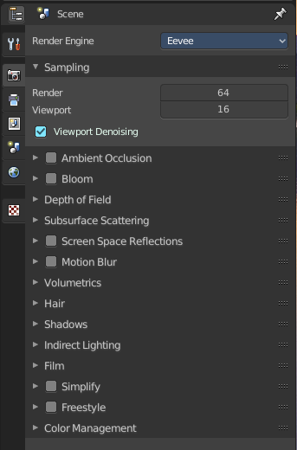
Rendering is the process of calculating a 2D image (or video) from your 3D scene. For this you use a so called render engine.
The Render tab contains the functionality and settings around the available render engines in Bforartists. And Choose the renderer with which you render your still or animation with.
There are three different render engines available. Workbench, Eevee and Cycles.
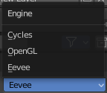

Cycles is a so called offline renderer. It is an unbiased physically correct renderer with some biased adjustments to make it usable for animations.
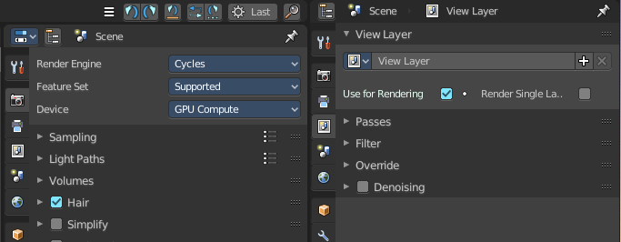
Cycles can render at the CPU or the GPU.
Eevee and Workbench are both so called Realtime Renderers. They both render at the GPU. Workbench relies at the OpenGL render features of the graphics card. Eevee is a full independent realtime render engine.
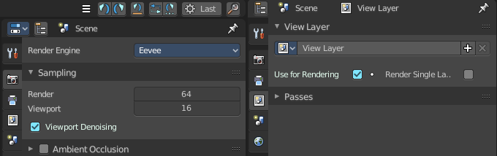
All three renderers have different settings. And the choice of the renderer influences the tab and panel content of the whole Scene section.
This content will be covered in the chapters for the other tabs.

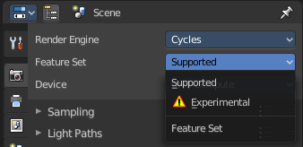
Cycles Feature Set
When you choose Cycles then you will see a new drop down box called Feature set. Cycles has two feature set settings. Supported and Experimental.
Supported means you have all common Cycles settings available.
Experimental means that you have access to some further experimental features of Cycles, which are somehow functional, but are still experimental features. Like Adaptive subdivision. Those features may or may not work proper. Use at own risk!

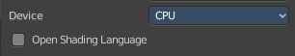
Cycles Device
When you turn on Cuda in the User Preferences then you will get a Device drop down box to choose if you want to render with the CPU or the GPU.

Open Shading Language
When you render with Cycles at the CPU, then you can choose to use the Open Shading Language.

Color Management panel - All Renderers
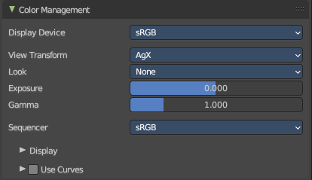
Color management is important to create renders and assets that are physically accurate and look great on multiple display devices. It is used both to ensure all parts of the pipeline interpret colors correctly, and to make artistic changes like exposure and color grading.
Bforartists color management is based on the OpenColorIO library. By using the same OpenColorIO configuration in multiple applications, the same color spaces and transforms will be available for consistent results.
In the Color Management panel you will find the settings around color management. It allows an artist to make sure that an image stays the same from rendering, to saving, to post-processing. Color management also allows an artist to tweak things like exposure, gamma, or the overall color grade.
The Color Management panel is the same for all render engines.

Display Device
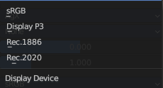
The device that the image is being viewed on. Your monitor.
Most computer monitors are configured for the sRGB color space.

View Transform
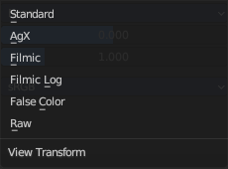
Choose between different ways to view the image on the same monitor.

Standard
Does no extra conversion besides the conversion for the display device.

AgX
AgX is a further development to Filmic. It brings an implementation of False Colors view transform, and replaces Filmic-based. It is available for all display devices.

Filmic
For more photo realistic results and better handling of high dynamic range. The contrast can be adjusted by changing the Look option for the Filmic view transform.

Filmic Log
Converts to Filmic log color space. This can be used for export to color grading applications, or to inspect the image by flattening out very dark and light areas.

Raw
Intended for inspecting the image but not for final export. Raw gives the image without any color space conversion.

False Color
Shows a heat map of image intensities, to visualize the dynamic range.

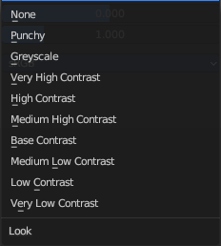
Look
Adjust the contrast.

Exposure
Used to control the image brightness (in stops) applied before color space conversion. The calculation is: output_value=render_value×2(exposure)

Gamma
Extra gamma correction applied after color space conversion. Note that the default sRGB or Rec709 color space conversions already include a gamma correction of approximately 2.2 (except the Raw and Log views), so this would be applied in addition to that.

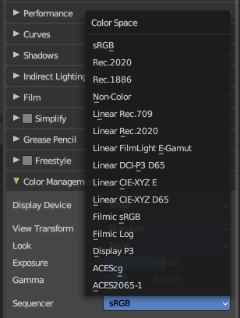
Sequencer Color Space
The color space that the sequencer operates in. By default, the sequencer operates in sRGB space, but it can also be set to work in Linear space like the Compositing nodes, or another color space. Different color spaces will give different results for color correction, cross fades, and other operations.

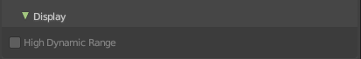
Display subpanel

Enable High Dynamic range dispaly in rendered viewport. This uncaps display brightness. And requires a monitor with HDR support and a veiw transform designed for HDR.
Filmic and AgX does not generate HDR colors. And so the option is greyed out.

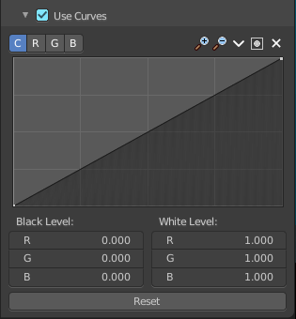
Use Curves subpanel
Adjust RGB Curves to control image colors before color space conversion.

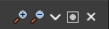
Navigation elements
The navigation elements at the top are described from left to right.

Zoom in and out
The two buttons with the magnifying glass at it zooms in and out in the curve window.

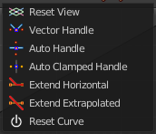
Tools
Tools is a menu that contains some cuve related tools.

Reset View
Resets the curve windows zoom.

Vector Handle
Set handle type to Vector.

Auto Handle
Set handle type to Auto.

Auto Clamped Handle
Set handle type to Auto Clamped.

Extend Horizontal
Causes the curve to stay horizontal before the first point and after the last point.

Extend Extrapolated
Causes the curve to extrapolate before the first point and after the last point, based on the shape of the curve.

Reset Curve
Resets the curve to the initial shape.


Use Clipping
Clipping options. Set up clipping for the stroke.

Delete Points
Deletes selected curve points.

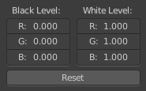
Black Level
The color that Black is mapped to.

White Level
The color that White is mapped to.

Hotkeys for Black and White Level

You may want to sample the black and white level colors directly in the image by clicking at an area. There are hotkeys for that.
Ctrl + Left Mouse click in the image sets the Black level value from that position.
Shift + Left Mouse click in the image sets the White Level value from that position.
To see the result you need to tick the View as Render button.
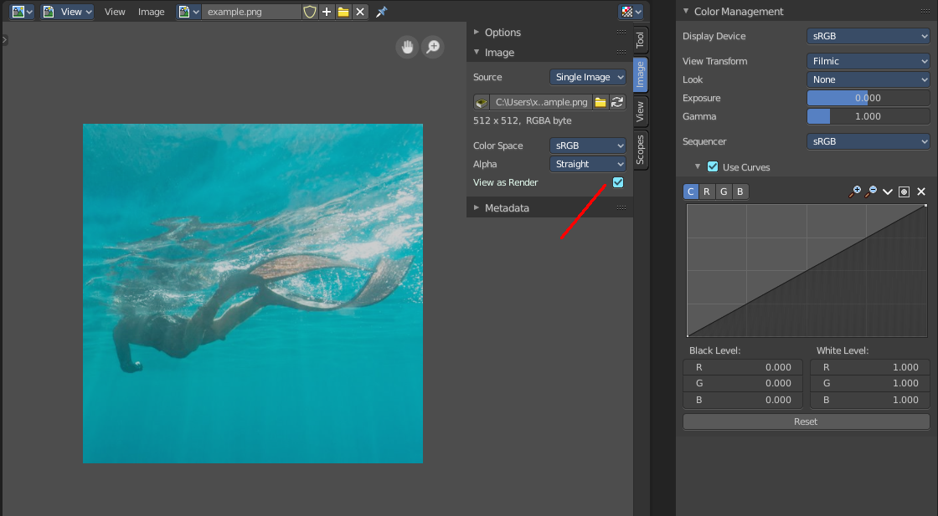

Reset
Resets the Curve and the Black and White Level values to the default values.

Cycles and Eevee - Freestyle panel

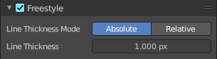
What is FreeStyle?
Freestyle is an edge- and line-based non-photorealistic (NPR) rendering engine that works on top of Cycles. It relies on mesh data and z-depth information to draw lines on selected edge types. Various line styles can be added to produce artistic or technical looks.
The two operating modes - Python Scripting and Parameter Editor - allow a diversity of line styles and results. Line styles such as Japanese big brush, cartoon, blueprint, thickness-with-depth are already pre-scripted in Python. The Parameter Editor mode allows intuitive editing of features such as dotted lines and easy setup of multiple line types and edge definitions.
There are more Freestyle settings in the View Layer tab wAdjust and define various parameters.
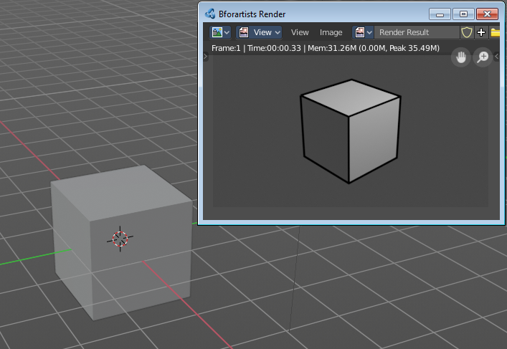
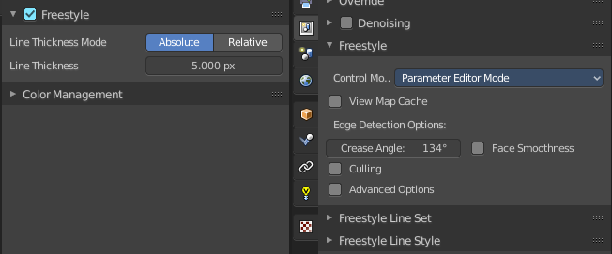

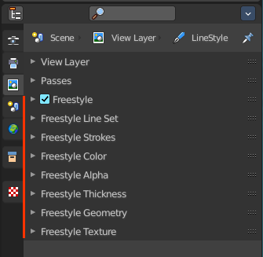
Enable
In the header is a checkbox where you can enable the Freestyle renderer.
Enabling the checkbox reveals the Freestyle Settings in the View Layer Properties.

Line Thickness Mode

Absolute
The line thickness is given by a user-specified number of pixels. The default value is 1.0.

Relative
The unit line thickness is scaled by the proportion of the present vertical image resolution to 480 pixels. For instance, the unit line thickness is 1.0 with the image height set to 480, 1.5 with 720, and 2.0 with 960.

Line Thickness
Line Thickness is only available for Absolute line thickness. The base line thickness in pixels.

Cycles - Sampling panel
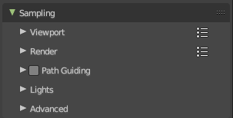
Adjust the samples for Cycles. And enable denoising.

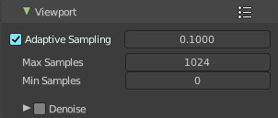
Viewport subpanel
Sampling settings for the Viewport rendering.

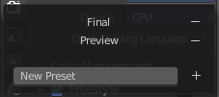
Presets
In the header you will find a Presets menu to choose between presets and define your own presets.

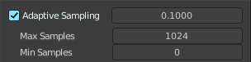
Adaptive Sampling
Automatically redcue the number of samples per pixel, based on estimated noise level.

Adaptive sampling threshold
The noise level step to stop sampling at. Lower values reduces noise at the cost of render time. A value of zero means to use the automatic setting based on number of AA samples.

Max Samples
Maximum samples for adaptive sampling.

Min Samples
Minimum samples for adaptive sampling. A value of zero means to use the automatic setting based on number of AA samples.

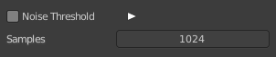
Samples
When Noise Threshold is off then you will see the Samples edit box. Number of samples to render.

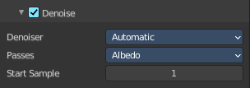
Denoise Sub Subpanel

Use Denoising Checkbox
Activate Denoising.

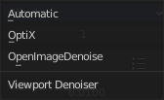
Denoiser

Automatic
Use the fastest denoiser that is available. If OptiX is available then OptiX. Otherwise OpenImageDenoiser.

OptiX
Use the OptiX Denoiser.

OpenImageDenoiser
Use the OpenImageDenoiser.

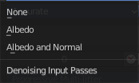
Passes
What input passes to use.

Start Sample
The sample to start denoising at.

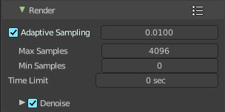
Render subpanel
Sampling settings for the final rendering.

Presets
In the header you will find a Presets menu to choose between presets and define your own presets.

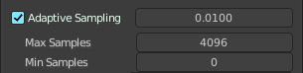
Adaptive Sampling
Automatically redcue the number of samples per pixel, based on estimated noise level.

Adaptive sampling threshold
The noise level step to stop sampling at. Lower values reduces noise at the cost of render time. A value of zero means to use the automatic setting based on number of AA samples.

Max Samples
Maximum samples for adaptive sampling.

Min Samples
Minimum samples for adaptive sampling. A value of zero means to use the automatic setting based on number of AA samples.

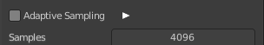
Samples
When Noise Threshold is off then you will see the Samples edit box. Number of samples to render.

Time Limit
When Noise Threshold is off then you will see the Time Limit edit box. Limit the render time. This ends the rendering process after the given time. A value of zero disables the limit.

Denoise Sub Subpanel

Use Denoising Checkbox
Activate Denoising.

Denoiser

Automatic
Use the fastest denoiser that is available. If OptiX is available then OptiX. Otherwise OpenImageDenoiser.

OptiX
Use the OptiX Denoiser.

OpenImageDenoiser
Use the OpenImageDenoiser.

Passes
What input passes to use.

Start Sample
The sample to start denoising at.

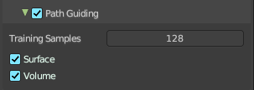
Path Guiding subpanel
Use path guiding for sampling paths. Path guiding incrementally learns the light distribution of the scene. And guides path into directions with high direct and indirect light contributions.

Training Samples
The maximum number of samples used for training path guiding. Higher values results in more accurate guiding at the cost of speed. A value of 0 will continue the training until the last sample.

Surface
Use guiding at surfaces.

Volume
Use guiding inside volumes.

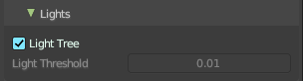
Lights subpanel

Light Tree
When ticked use existing light tree. This will sample multiple lights more efficiently.

Light Threshold
When Light Tree is unticked Light Threshold becomes available. Terminate light samples below this value. This speeds up the rendering at the cost of noise. A value of zero will disable the test. Then all light value will be calculated.

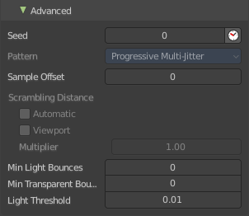
Advanced subpanel

Seed
Seed value for integrator to get different noise patterns.

Animate Seed
The clock icon besides the Seed value. Enable it to get different seed values for animation. Without animated seed you will get visible patterns in animations.

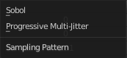
Pattern
Random sampling pattern used by the integrator. You need to turn off Noise Threshold in the Render panel to activate and use the Sampling Pattern.

Sobol
Uses a Sobol pattern to decide the random sapling pattern used by the integrator.

Progressive Multi-Jitter
Uses a progressive Multi-Jitter pattern to decide the random sapling pattern used by the integrator.

Sample Offset
Number of samples to skip when starting the render.

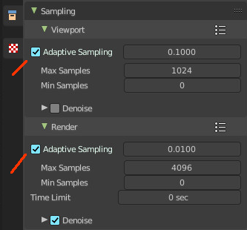
Scrambling Distance
Speeds up the rendering times at the gpu at cost of possible artifacts. You need to turn off Adaptive Sampling in the Render or Viewport panel to activate and use the Scrambling Distance.

Adaptive
Instead of a fixed scrambling distance you can use this adaptive method. It is based on the sample count.

Viewport
Also use the scrambling distance in the viewport.

Min Light Bounces
The minimum bounces of light rays.

Min Transparent Bounces
The minimum number of transparent bounces.

Light Threshold
Terminates light samples when the light contribution is below this value. This gives more noise, but renders faster. Type in 0 to disable this feature.

Cycles - Light Paths panel
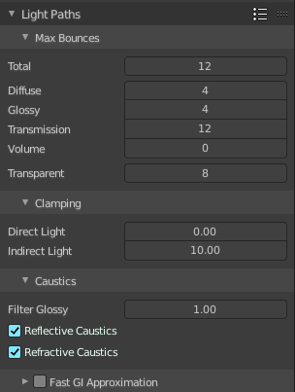
Here you will find all settings regarding light paths.

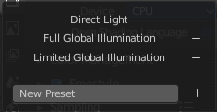
Presets
In the header you will find a Presets menu to choose between presets and define your own presets.

Max Bounces
A sub menu with the Maximum Bounces settings.

Total
Total maximum number of bounces.

Diffuse
Maximum number of diffuse bounces.

Glossy
Maximum number of glossy bounces.

Transmission Bounces
Maximum number of transmission bounces.

Volume
Maximum number of volume scattering bounces.

Transparent
Maximum number of transparency bounces.

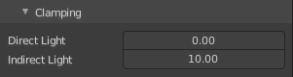
Clamping
A sub menu with the Clamping settings. Clamping will reduce noise at the cost of accuracy.

Direct Light
The maxium value for a direct sample. Zero means disabled.

Indirect Light
The maximum value for a indirect sample. Zero means disabled.

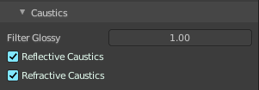
Caustics
A sub menu with caustics and filter glossy settings.

Filter Glossy
When using a value higher than 0.0, this will blur glossy reflections after blurry bounces, to reduce noise at the cost of accuracy. 1.0 is a good starting value to tweak.
Some light paths have a low probability of being found while contributing much light to the pixel. As a result these light paths will be found in some pixels and not in others, causing fireflies. An example of such a difficult path might be a small light that is causing a small specular highlight on a sharp glossy material, which we are seeing through a rough glossy material. In fact in such a case we practically have a caustic.
With path tracing it is difficult to find the specular highlight, but if we increase the roughness on the material, the highlight gets bigger and softer, and so easier to find. Often this blurring will hardly be noticeable, because we are seeing it through a blurry material anyway, but there are also cases where this will lead to a loss of detail in lighting.

Reflective Caustics
Disable reflective caustics. Path tracing supports rendering of caustics with a sufficient number of samples. But in practice it may be inefficient to the point that there is just too much noise.

Refractive Caustics
Disable refractive caustics. Path tracing supports rendering of caustics with a sufficient number of samples. But in practice it may be inefficient to the point that there is just too much noise.

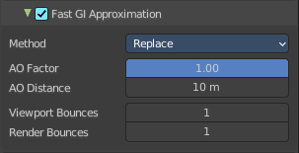
Fast GI approximation subpanel
Approximate diffuse indirect light with background tinted ambient occlusion.
This method provides a fast alternative to full global illumination, for interactive viewport rendering or final renderers with lower quality.

Fast GI Approximation checkbox
The checkbox in the header activates the Fast GI Approximation.

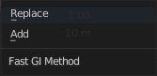
Method
The fast gi method.

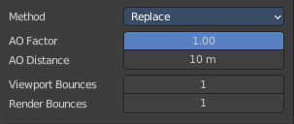
Replace
Replace global illumination with ambient occlusion after a specified number of bounces.

AO Factor
Factor of ambient occlusion blending.

AO Distance
The length of the rays that are used for Ambient Occlusion. Defines how far any other faces gives the occlusion effect.

Viewport Bounces
Use approximate global illumination after this number of light bounces in the viewport. A value of 0 deactivates the feature.

Render Bounces
Use approximate global illumination after this number of light bounces in the rendering. A value of 0 deactivates the feature.

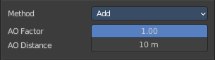
Add
Add ambient occlusion to diffuse surfaces

AO Factor
Factor of ambient occlusion blending.

AO Distance
The length of the rays that are used for Ambient Occlusion. Defines how far any other faces gives the occlusion effect.

Cycles - Volumes panel

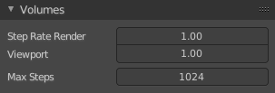
Adjust the volume sampling.

Step Rate Render
Globally adjust detail for volume rendering for the final rendering. Lower values give more accurate and detailed results but also increased render time.

Step Rate Viewport
Globally adjust detail for voljme rendering for the viewport rendering. Lower values give more accurate and detailed results but also increased render time.

Max Steps
Maximum number of steps through the volume before giving up, to protect from extremely long render times with big objects or small step sizes.

Cycles - Curves panel
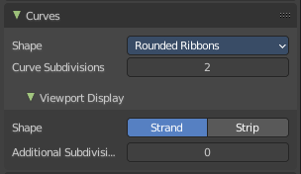
Adjust the settings for Hair particles.

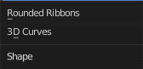
Shape
Choose between the shape 3D Curves and Rounded Ribbon.

Curve Subdivisions
Rounded Ribbons, the number of subdivisions at the curves.

Viewport Display subpanel
How to display the hairs in the viewport.

Shape
The hair shape type. Stand or Strip.

Additional Subdiv
Additional subdivision along the hair.

Cycles - Simplify panel
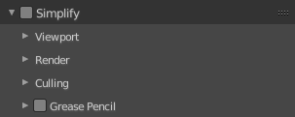

Sometimes you want to simplify the rendering without to loose the already tweaked settings and adjustments. For test renderings for example. Simplify allows you to set global limits on subdivision, shadow samples and more.

Enable
In the header is a checkbox to enable Simplify.

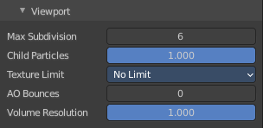
Viewport
This section affects the rendering with cycles in the Viewport.

Max Subdivisions
Limit the number of maximum subdivisions.

Child Particles
Limit the number of child particles.

Texture Limit
Automatically scales down textures to the chosen value.

AO Bounces
Limit the number of Ambient Occlusion Bounces.

Volume Resolution
Simplify volumes by adjusting volume percentage of volume objects in viewport.

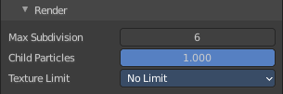
Render
This section affects the final rendering.

Max Subdivisions
Limit the number of maximum subdivisions.

Child Particles
Limit the number of child particles

Texture Limit
Automatically scales down textures to the chosen value.

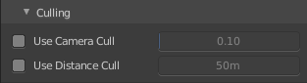
Culling
Contains Culling settings. Culling means that the affected geometry is excluded from calculation.

Use Camera Cull
Allow objects to be culled based on the Camera Frustum. Frustum is the region of the 3D space that gets displayed by the camera, the field of view.

Camera cull margin
The margin for the camera space culling.

Use Distance Cull
Allow objects to be culled based on the distance to the camera.

Distance
The distance after which the objects gets culled away.

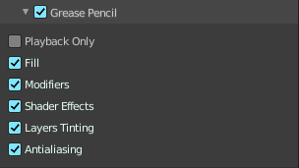
Grease Pencil

Playback Only
Simplify the grease pencil strokes only during playback.

Fill
Display Fill strokes in viewport.

Modifiers
Display Modifiers.

Shader Effects
Display Shader effects.

Layers Tinting
Display layer tint.

Antialiasing
Use antialiasing to smooth stroke edges.

Cycles - Motion Blur panel
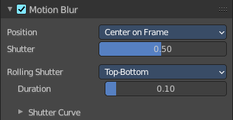
Enable Motion Blur and adjust the settings.
Each object has also its own settings to control motion blur. These options can be found in the corresponding Object tab of the Properties editor.

Enable
In the header is a checkbox to enable Simplify.

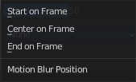
Position
Controls at what point the shutter opens in relation to the frame.

Shutter
Time between frames over which motion blur is computed. Shutter time 1.0 blurs over the length of 1 frame, 2.0 over the length of two frames, from the previous to the next.

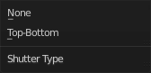
Rolling Shutter
Enable Rolling Shutter.

Duration
With method Top - Bottom only. Controls balance between pure rolling shutter effect and pure motion blur effect. With zero being no rolling shutter and one being all rolling shutter.

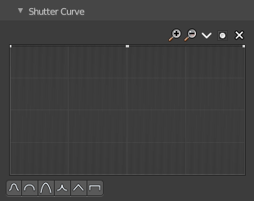
Shutter Curve
Sutter curve is a sub menu wAdjust a curve for the shutter effect.

Navigation elements
The navigation elements at the top are described from left to right.

Zoom in and out
The two buttons with the magnifying glass at it zooms in and out in the curve window.

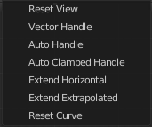
Tools
Tools is a menu that contains some curve related tools.

Reset View
Resets the curve windows zoom.

Vector Handle
Set handle type to Vector.

Auto Handle
Set handle type to Auto.

Auto Clamped Handle
Set handle type to Auto Clamped.

Extend Horizontal
Causes the curve to stay horizontal before the first point and after the last point.

Extend Extrapolated
Causes the curve to extrapolate before the first point and after the last point, based on the shape of the curve.

Reset Curve
Resets the curve to the initial shape.

Use Clipping
Clipping options. Set up clipping for the stroke.

Delete Points
Deletes selected curve points.

X and Y values
The coordinates of the currently selected curve point.

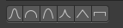
Presets
At the bottom you can find some curve presets.

Cycles - Film panel
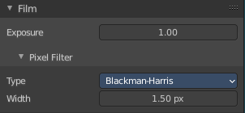

Exposure
Exposure can be used to change the brightness of an image. Different then the Exposure option found in the Color management panel this exposure option works is on the data while the Color management exposure is on the view.

Pixel Filter
The Pixel Filter randomly changes the coordinates of every sample with the given distribution. For example: When the Sobol Sampling Pattern samples near the edge of the pixel, the neighboring pixel might be lit instead with a rather high probability. Pixel filter is used to get rid of aliasing on the sharp edge of very bright objects, like mesh lights.

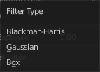
Type
Choose the pixel filter type.

Width
Adjust the pixel filter width.

Cycles - Performance panel
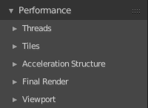
Settings to influence the render performance.

Presets
Performance presets can be applied to quickly configure Cycles.

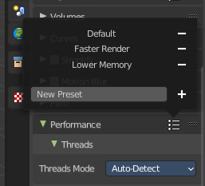
Default
This preset are the default cycles settings.

Faster Rendering
This preset is dedicated to speed with higher memory usage. This may be more unstable due to hardware limits.

Lower Memory
This preset is dedicated to lower memory. This may cause longer renders.

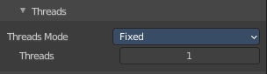
Threads
With threads, you are able to to assign as many cores as you need from your CPU as dedicated resources. Default is Auto-Detect.

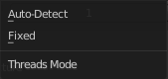
Mode

Auto-detect
Automatically chooses the amount threads to match the number of logical processors on your computer.

Fixed
Manually choose the amount threads to use for rendering.

Threads
Just active when you choose Fixed. Number of threads that you want to use.

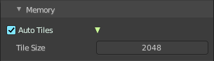
Memory

Auto Tiles
Automatically render high resolution images in tiles to reduce memory usage. Tiles are cached to disk while rendering, to save memory.

Tile Size
The tile size for the tiles.

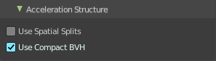
Acceleration Structure

Use Spatial Splits
Spatial splits improve rendering performance in scenes with a mix of large and small polygons. The downsides are longer BVH build times and slightly increased memory usage.

With CPU rendering:

Use compact BVH
Use a compact BVH code structure that uses less ram. This option renders slower.

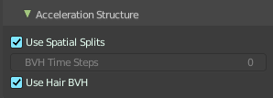
With GPU rendering:

BVH Time Steps
Is just active when Spatial Splits is off. Split BVH Primitives by this number of time steps. This speeds up rendering, but requires more memory.

Use Hair BVH
Use a special type of BVH for rendering hair. The bounding boxes are not axis aligned allowing a spatially closer fit to the hair geometry. Disabling this option will reduce memory, at the cost of increasing hair render time.

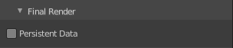
Final Render

Persistent Data
Keep image data in memory after rendering, for faster re-renders at the cost of extra memory usage when performing other tasks in Blender.

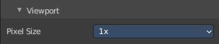
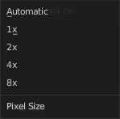
Viewport
This settings is for rendering in the Viewport.

Pixel Size
Pixel Size for Viewport Rendering.

Cycles - Bake panel

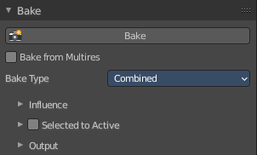
Texture baking is the process to bake specific informations from one object into the texture or the vertex colors of another object. Ambient Occlusion. Or a Normal Map for example.

NOTE
Baking into textures requires to have a working UV mapping and a texture at the target object!

How to use: Select the source object where you want to bake from, hold down Shift, select the target object where you want to bake to, so that both objects are selected. Adjust the settings to your needs. Then hit the Bake button.

NOTE
The Bake panel is visible in all Modes. But you have to bake in Object Mode.

Settings for all Texture types
Most settings in the Bake panel are available for all texture types.

Bake Button
Start the bake process.

Bake from Multires
Bake directly from multi resolution object.

Bake Type
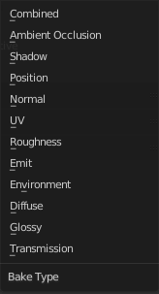
Bake Mode is a drop-down box to choose what type of information you want to bake from the source object into the texture or the vertex colors of the target object.
You can bake Subsurface, Transmission, Glossy, Diffuse, Environment, Emit, UV, Normal, Shadow, Ambient Occlusion and Combined.

Combined
Bakes the full rendering, means materials, textures, lightning, into the texture of the target object. Except Specularity.

Ambient Occlusion
Bakes ambient occlusion as specified in the World panels. Ignores all lights in the scene.

Shadow
Bakes the Shadow into the texture of the target object.

Position
Bake out a position map. Position maps stores the distance from the floor. Which allows to add a dirtmap above some ground for example.

Normal
Creates a Normal map by using the normals of the source object, and baking them as colors into the texture of the target object.

UV
Bakes colors of materials and textures only, without shading.

Roughness
Bakes the Roughness of a material into the texture of the target object.

Emit
Bakes the Emission or the glow color of a material into the texture of the target object.

Environment
Bakes the Environment texture into the texture of the target object. As seen from the center of the object.

Diffuse
Bake the diffuse texture of the source object into the texture of the target object.

Glossy
Bakes the Glossy Passes of a material into the texture of the target object.

Transmission
Bakes the transmission Passes of a material into the texture of the target object.

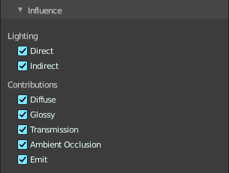
Influence Sub panel
Adjust what data contributes to the bake process. The items are self explaining.
The content changes, dependent of what type you want to bake.

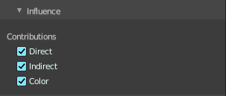
Glossy, Diffuse

Direct
Add direct Light.

Indirect
Add indirect Light.

Color
Add Color.

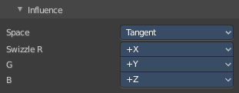
Normal

Space
A drop-down box to chooses the Normal Space to use.

Swizzle
Axis to bake in red, green and blue channels.

Combined

Direct
Bake directly from Multires mesh.

Indirect
Normalizes without using material settings.

Diffuse
Bake with Diffuse.

Glossy
Bake with Glossy.

Transmission
Bake with Transmission.

Subsurface
Bake with Subsurface.

AO
Bake with Ambient Occlusion.

Emit
Bake with Emit.

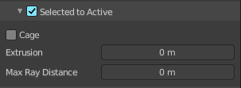
Selected to Active
The usual way to bake is first select the Source Object, where you want to bake from, hold down Shift, select the target object where you want to bake to, so that both objects are selected. Then hit the Bake button. That's Selected to Active.

Extrusion
Inflate the active object by the specified distance for baking.

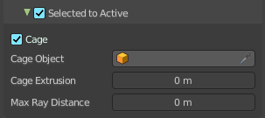
Cage
Cast Rays to active object from a cage. A value of zero means unlimited ray length.

Cage Object
Pick an object to use as a cage. Usually you create this cage object by duplicating the original object, and extrude out the faces along their normals until they fully include the original object.

Ray Distance
Distance to use for the inward ray cast when using Selected to Active.

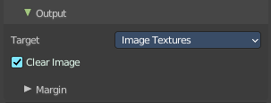
Output Sub panel

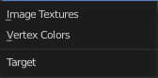
Target
To what target to bake. You can bake to images or you can bake to the vertex colors of the mesh. Note that baking to vertex colors has no further options.

Clear Image
Clear clears the target image before baking.

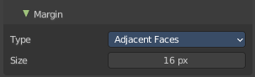
Margin sub subpanel
Adjust the margin width.

Type
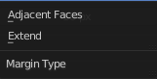
The margin type.

Adjacent Faces
Use pixels from adjacent faces across UV seams to create the margin.

Extend
Use the pixels at the inside of the border UV seams, and extend from there to create the margin.

Size
The size of the margin around the UV patches.

Workbench - Lighting panel
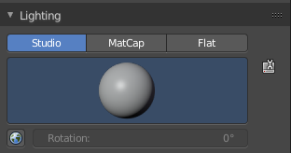
The Workbench renderer uses Open GL. OpenGL rendering is not influenced by the lights that you place in the workspace. But by a special OpenGL light setup. It can be tweaked in the Lighting panel and the User Preferences.

Flat
Use a flat lighting.

Studio
Use a Studio light setup.

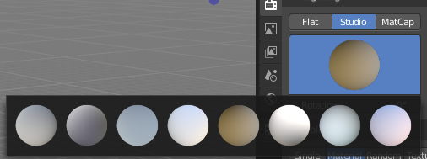
Light library browser
Choose a predefined studio light setup.

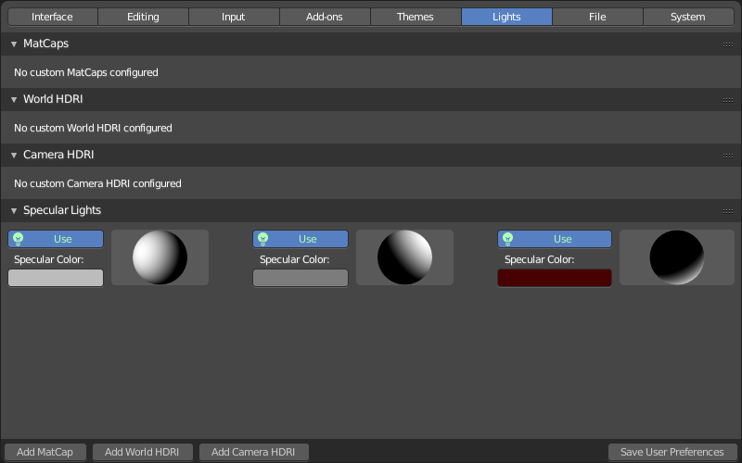
Rotation
Rotate the studio light setup.

User Preferences
A click at this button opens up the user preferences where you can add and manage the OpenGL Lights.

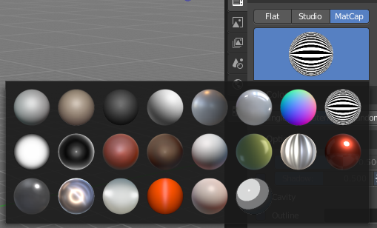
Matcap
Use Matcaps to render the scene.

User Preferences
A click at this button opens up the user preferences where you can add and manage the Matcaps.

Flip Matcap
Flips the matcap.

Workbench - Color panel

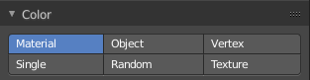
Workbench renderer is meant for fast preview display. It does not use materials like Eevee or Cycles. You choose a color instead.
This panel allows you to define the color of the surface of the object. This settings are also dependent of the chosen lighting.

Material
Uses the material including textures for the mesh.

Object
Uses the Object color.

Vertex
Uses the Vertex color.

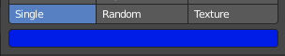
Single
Uses a single color for the selected mesh.

Random
Uses a random color for the mesh.

Texture
Renders the texture, and ignores the material settings.

Workbench - Options panel
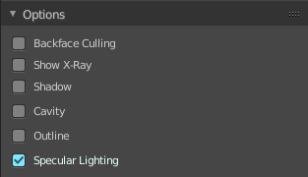

X Ray
Render the faces transparent.

Backface Culling
Don't calculate back faces.

Show X-Ray
Set X-Ray active, and adjust the amount of alpha that is used for the x-ray effect.
Note that you can have either X-Ray or Shadow and Cavity active. Not both at the same time.

X-Ray Alpha
This slider shows up when you tick Show X Ray. Adjust the intensity.

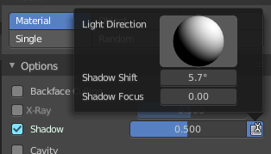
Shadow
Render Shadow.

Shadow Intensity
This slider shows up when you tick Shadow. Adjust the intensity.

Shading Shadow Options
Adjust a shadow shift relative to the light source.

Cavity
Show Cavity. Cavity highlights ridges and valleys in the scene geometry. Once activated Cavity shows some further settings.

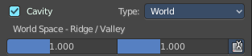
World
Draw the cavity shading in world space.

World Space / Ridge Valley
Factor for the cavity ridges and valleys.

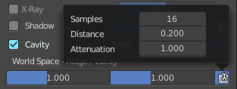
Shading Options
Adjust samples, distance and attenuation for the cavity ridges and valleys.

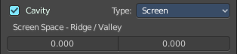
Screen
Draw the cavity shading in Screen space.

Screen Space / Ridge Valley
Factor for the curvature ridges and valleys.

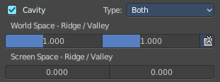
Both
Draw the cavity shading in both, World Space and Screen space.
Settings see above.

Outline
Show the not selected objects with an outline.

Outline Color
Define the color of the outline for not selected objects.

Specular Lighting
Render specular highlights.

Eevee - Sampling panel
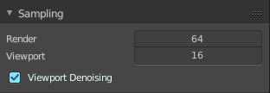

Viewport Samples
The number of samples when rendering in the viewport.

Render Samples
The number of samples when rendering to file.

Viewport Denoising
Denoise Image. The temporal re-projection can cause some ghosting.

Eevee - Ambient Occlusion panel
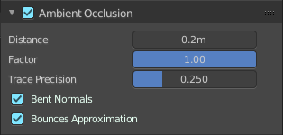
Ambient occlusion is a self shadowing effect.

Enable
In the header you will find a checkbox to enable the Ambient Occlusion.

Distance
The distance of the object to contribute to the ambient occlusion.

Factor
The blend factor

Trace Precision
Precision of the horizon search

Bent Normals
Compute the main non occluded direction to sample the environment

Bounces Approximation
An approximation to simulate light bounces gives less occlusion on brighter objects.

Eevee - Bloom panel

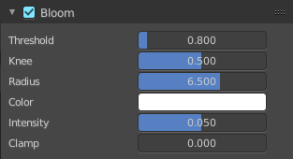
Enable
In the header you will find a checkbox to enable the Bloom.

Threshold
Filters out pixel that are below this level of brightness.

Knee
Makes transition between under / over threshold gradual.

Radius
Bloom spread distance.

Color
The color of the bloom effect.

Intensity
Blend Factor.

Clamp
Maximum intensity a bloom pixel can have.

Eevee - Depth of Field panel
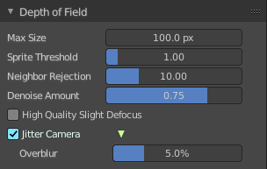

Max Size
The maximum size of the bokeh shape for Depth of Field. Lower is faster.

Sprite Threshold
Brightness threshold for using sprite base depth of field.

Neighbor Rejection
The maximum brightness to consider when rejecting bokeh sprites based on neighborhood. Lower is faster.

Denoise Amount
Amount of flicker remove applied to bokeh highlights.

High Quality Slight Defocus
Sample all pixels in almost in-focus regions to eliminate noise.

Jitter Camera
Jitter the camera to create accurate blurring by using render samples.

Overblur
Apply blur to each jittered sample to reduce undersampling artifacts.

Eevee - Subsurface Scattering panel

Subsurface scattering is a mechanism of light transport through the object. It penetrates the surface of a translucent object, is scattered by interacting with the material, and exits the surface at a different point.

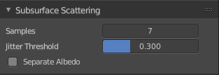
Enable
In the header you will find a checkbox to enable the Subsurface Scattering.

Samples
Number of samples to compute the scattering effect.

Jitter Threshold
Rotate samples that are below this value.

Separate Albedo
Avoid albedo being blurred by the subsurface scattering. This feature uses more memory.

Eevee - Screen Space reflections panel

Contains settings around the Screen Space reflections.
Screen Space Reflections is a common technique in games. It reuses the information that is already on screen for reflections. It doesn't reflect geometry outside of the camera though.

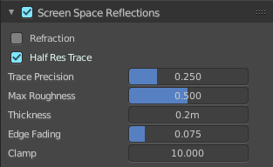
Enable
In the header you will find a checkbox to enable the Subsurface Scattering.

Refraction
Enable Screen Space refraction.

Half Res Trace
Ray trace at a lower resolution.

Trace Precision
The precision of the screen space ray-tracing.

Max Roughness
Do not ray-trace reflections that are above this value.

Thickness
Pixel thickness used to detect intersections.

Edge Fading
Screen percentage used to fade the Screen Space Reflection.

Clamp
Clamp Pixel intensity to remove noise.

Eevee - Motion Blur panel

Contains settings for motion blur.

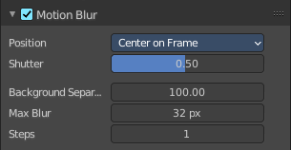
Enable
In the header you will find a checkbox to enable the Subsurface Scattering.

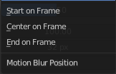
Position
Offset for the shutters time interval. This allows to change the motion blur trails.

Shutter
Time taken in frames between shutter open and close.

Background Separation
Separate background elements from foreground elements. Lower values will reduce background bleeding onto foreground elements

Max Blur
The maximum blur distance a pixel can spread over.

Steps
The accuracy of motion blur. Higher values results in higher accuracy and higher render times.

Eevee - Volumetric panel

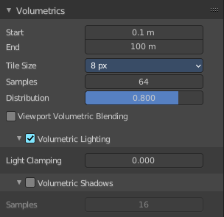
Contains volumetrics settings.

Start
The start distance for volumetrics.

End
The end distance for volumetrics.

Tile Size
The quality of the volumetrics effect. The lower the size the higher the quality and ram usage.

Samples
Number of samples to compote for the volumetrics effect.

Distribution
Distribute more samples closer to the camera.

Viewport Volumetric Blending
Enable volumetrics blending with previous frame in viewport. Attention, this setting is just for the viewport. The final rendering is not affected.

Volumetric Lighting

Enable
In the header you will find a checkbox to enable Volumetric Lighting.

Light Clamping
The maximum light contribution.

Volumetric Shadows

Enable
In the header you will find a checkbox to enable Volumetric Shadows.

Samples
Number of samples to compute volumetric shadowing.

Eevee - Curves panel

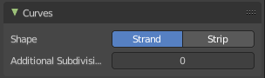
Shape
Choose if the hair is displayed as strand or as strip.

Additional Subdiv
Additional subdivision along the hair.

Eevee - Shadows panel
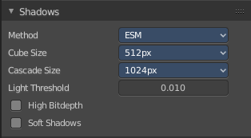
Contains settings regarding shadows.

Method
Choose between ESM and VSM method for the shadow. ESM stands for exponential shadow mapping. VSM stands for Variance shadow mapping.

Cube Size
The cube shadows resolution.

Cascade Size
Directional shadows resolution.

High Bit depth
Use 32 bit shadows. Low bit depth uses 8 bit.

Soft Shadows
Create soft shadows.

Eevee - Indirect Lighting panel
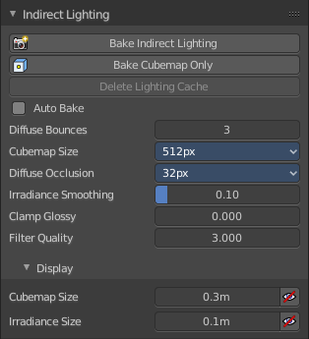
Indirect lighting can be baked to speed up the rendering process.
Eevee uses irradiance probes to calculate indirect lighting.

Bake Indirect Lighting
Bake both, the irradiance grids and reflection cube maps.

Bake Cubemap Only
Bakes only the reflection cube maps.

Delete Lighting Cache
Delete baked informations from cache.

Auto Bake
Auto bake indirect lighting when editing probes.

Diffuse Bounces
Number of times the light is reinjected inside light grids. 0 will disable indirect diffuse light.

Cubemap Size
The size of the cube maps.

Diffuse Occlusion
The size of the shadow map applied to each irradiance sample.

Irradiance Smoothing
Smooth the irradiance lightning. But this might introduce light bleeding.

Clamp Glossy
Clamp Pixel intensity to reduce noise inside glossy reflections from reflection cube maps. A value of 0 disables the clamping.

Filter Quality
Take more samples during cubemap filtering to remove artifacts.

Display

Cubemap Size
Size of cubemap spheres to debug captured light.

Irradiance Size
Size of the irradiance sample spheres to debug captured light.

Eevee - Film panel
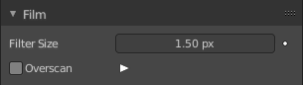

Filter Size
The width over which the reconstruction filter combines samples.

Animate Property
This property can be animated. Activating this button sets a keyframe.

Overscan
Internally render past the image borders to avoid screen space effects disappearing.

Overscan Size
How much bigger the image should be internally rendered.

Eevee + Workbench - Simplify panel
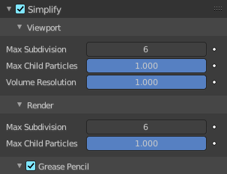
Sometimes you want to simplify the rendering without to loose the already tweaked settings and adjustments. For test renderings for example. Simplify allows you to simplify the rendering.

Enable
In the header is a checkbox to enable Simplify.

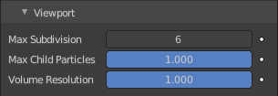
Viewport
This section affects the rendering with Eevee in the Viewport.

Max Subdivisions
Limit the number of maximum subdivisions.

Child Particles
Limit the number of child particles.

Volume Resolution
Simplify volumes by setting the resolution percentage of volume objects in viewport

Animate Property
This properties can be animated. Activating this button sets a keyframe.

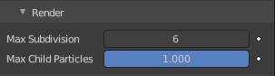
Render
This section affects the rendering with Eevee to file.

Max Subdivisions
Limit the number of maximum subdivisions.

Child Particles
Limit the number of child particles.

Animate Property
This properties can be animated. Activating this button sets a keyframe.

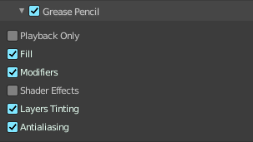
Grease Pencil
This section affects Grease Pencil drawings.

Playback Only
Simplify Grease Pencil only during animation playback.

Fill
Display Fill strokes in the Viewport.

Modifiers
Apply modifiers in the viewport.

Shader Effects
display shader effects.

Layers Tinting
Display layers tint.

Antialiasing
Use antialiasing to smooth stroke edges.

